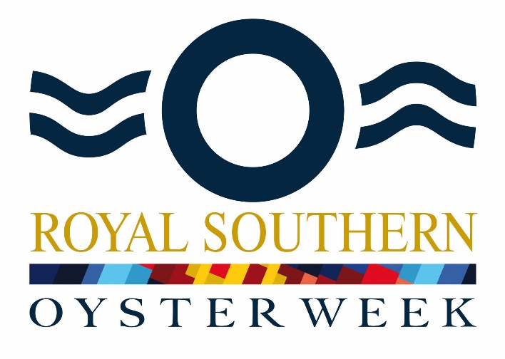
25th June – 29th June 2018

The Royal Southern welcomes participants to the 2018 Oyster Week comprising five days of cruising, racing and socialising for Oyster yachts, their owners and crews. All Oyster Sailing and Motor Yachts are welcome; there will be separate Notices of Race for Sailing and Motor yachts.

NOTICE OF RACE (Sailing Yachts)

Organisation

The event is organised by the Royal Southern Yacht Club.

The headquarters will be the Royal Southern Yacht Club, Hamble, SO31 4HB. A Committee Desk will operate at the Club from 1200 to 1730 BST on Monday 25th June.

Rules

The event is governed by the current Racing Rules of Sailing (RRS).

Rule 31 of the RRS (touching a mark) shall apply at all times

RRS 55 is changed by adding to the rule: “Material used to band spinnakers shall not be considered to be trash for the purposes of this rule.”

The Sailing Instructions (SIs) will be made available on the Royal Southern Yacht Club Website www.royal-southern.co.uk no later than Monday 18th June and copies may be collected from the Club Sailing Office.

This Notice of Race (NoR) may be changed by a subsequent amendment or by the Sailing Instructions (SIs). In the event of conflict between the NoR and the SIs, the SIs shall prevail; this changes RRS 63.7.

Competitors must be aware of and comply with the directions Bylaws and Notices to Mariners issued by the Harbour Authorities in whose waters racing takes place.

Anchors may be carried in their usual stowage position, in the stemhead, whilst racing.

By participating in the event, owners and their guests and crews grant, at no cost, the absolute right and permission for the Organising Authority and event supporters to use their name, voice, image, likeness and representation of their boat in any media (being television, print, and internet media) including video footage, for the purposes of reporting, advertising and promotion.

Eligibility and Entry

The Oyster Week is open to all Oyster Sailing Yachts.

Entries must be made online at through the Royal Southern website (royal-southern.co.uk/Calendar and with the appropriate fee no later than Friday 8th June 2018. The entry fee is £300 per boat up to 60ft in LOA, £400 for boats of 60ft or more LOA.

Late entries will be admitted at the discretion of the Organising Authority. A late entry fee of £50 may be payable.

All Owners/Skippers must register at the event Committee Desk in the Royal Southern on arrival on 25th June where they will be given a Regatta pack.

There will be a Skippersʼ Briefing at 1730 BST on Monday 25th June in the North Dining Room at RSrnYC. At least one, at most two, representatives from each yacht must attend. A yacht which has no representative at the skipper’s briefing will not be allowed to race.

All communications up to 1200 hrs BST on Monday 25th June are to be with the Sailing Secretary, Royal Southern Yacht Club: 023 8045 0302, sailing@royal-southern.co.uk .

Safety

Boats shall be suitably equipped and configured for the conditions they expect to meet.

A final Crew List shall be handed to the Committee Desk at Registration.

Yachts shall be adequately crewed so that the vessel can be operated safely. For racing the minimum competent crew to be on board (including the skipper) is:

Sailing Yachts up to and including the Oyster 575, 3

above Oyster 575 up to and including Oyster 66, 4

above Oyster 66 up to and including Oyster 82, 5

above Oyster 82, as agreed by the Committee

Participants are responsible for carrying the navigational charts and equipment they consider necessary. The following paper charts are recommended: Admiralty Solent & Approaches Portfolio SCF 5600.

All boats shall carry a functioning VHF Radio capable of receiving all the usual marine channels including M1 (37) and M2.

When flag “Y” is displayed by the Committee Boat the appropriate personal flotation device shall be worn so as to be visible to other boats.

A yacht may be inspected at any time. If the Committee deems a yacht to be unsafe her entry may be rejected or she may be liable to disqualification or such other penalty as may be prescribed by the Committee.

In order to avoid potentially dangerous situations yachts may use their engines to motor clear provided this is done in such a way as not to give unfair advantage. Yachts that use their engines in this way shall report the circumstances to the Race Committee within an hour of finishing any race, which may apply a penalty.

Identification

Yachts shall have sail numbers on their mainsails or other forms of identification agreed in advance by the Race Committee.

Yachts will be issued with a complimentary Regatta flag at registration which shall be displayed during racing.

Yachts shall not display ensigns while racing.

Yachts that retire from a race should display their Ensign to indicate that they have retired and should not cross the finishing line. A Yacht displaying her ensign while crossing the finishing line shall be deemed to have retired and shall not be given a finishing time.

Race Schedule

The intended race schedule is:-
Date |  | First start | HW Portsmouth
Tue 26 June | Races 1 and 2. Two short races in Central Solent | 1030 BST | 1125 BST 4.17m.
Wed 27 June | Race 3. Race in Central Solent | 1030 BST | 1206 BST 4.27m.
Thu 28 June | Race 4. Race round NAB Tower | 1000 BST | 1245 BST 4.34m.
Fri 29 June | Race 5. Race in Central Solent | 1030 BST | 1322 BST 4.39m.

Time limits and details of courses shall be given in the SIs.

The Organising Authority may make changes to the planned event Programme to take account of weather and other conditions.

Protests

Protests shall be notified to the Race Committee when crossing the finishing line and be lodged in writing on the approved RYA Protest Form at Race Headquarters within 1 hour of finishing. Protest Forms are available at Race Headquarters. The constitution of a Protest Committee will be at the discretion of the Organising Authority.

Penalties

Time penalties shall apply for breaches of a Part 2 rule or rule 31, this changes Rule 44.

Penalties shall be at the discretion of the Race Committee.

Scoring for Sailing Yacht Races

The fleet may be divided into two classes by size and number at the discretion of the Organising Committee.

Yachts shall declare the sails they are using at the start of each Race.

Races will be under "Oyster Handicap" as decided by the Organising Authority whose decision shall be final.

Races shall be scored using the Low Point System in RRS Appendix A except that

A yacht that does not start a race shall score 36 for that race.

A yacht that is disqualified for a race shall score 36 for that race.

There shall be no discards.

Prizes

The overall winners of each Class will each receive the Oyster Regatta Trophy. The trophies are perpetual and arrangements for their safe keeping, insurance and return must be agreed.

Prizes will be presented to the first three yachts in each class, in every race, at a daily prize-giving.

Major prizes will be presented at the Prize Giving Party on Friday 29th June 2018.

Risk Statement

Rule 4 of the Racing Rules of Sailing states: “The responsibility for a boat’s decision to participate in a race or to continue racing is hers alone.”

Sailing is by its nature an unpredictable sport and therefore inherently involves an element of risk. By taking part in the event, each competitor agrees and acknowledges that:
- They are aware of the inherent element of risk involved in the sport and accept responsibility for the exposure of themselves, their crew and their boat to such inherent risk whilst taking part in the event;
- They are responsible for the safety of themselves, their crew, their boat and their other property whether afloat or ashore;
- They accept responsibility for any injury, damage or loss to the extent caused by their own actions or omissions;
- Their boat is in good order, equipped to sail in the event and they are fit to participate;
- The provision of a race management team, patrol boats if any and other officials and volunteers by the event organiser does not relieve them of their own responsibilities;
- The provision of patrol boat cover if any is limited to such assistance, particularly in extreme weather conditions, as can practically be provided in the circumstances;
- They are responsible for ensuring that their boat is equipped and seaworthy so as to be able to face extremes of weather; that there is a crew sufficient in number, experience and fitness to withstand such weather; and that the safety equipment is properly maintained, stowed and in date and is familiar to the crew; and
- Their boat is adequately insured, with cover of at least £3 million against third party claims. This is a condition of participation in Royal Southern Oyster Week. Any inspection of a boat by the race committee does not reduce the responsibilities set out in this Notice of Race.

Further Information
Sailing Secretary, Royal Southern Yacht Club, Rope Walk, Hamble, Hampshire, SO31 4HB Tel: 023 8045 0302 - Fax: 02380 450310. email: sailing@royal-southern.co.uk - Website: www.royal-southern.co.uk
End of Notice of Race

Oyster Week 25th – 29th June 2018

Draft Programme

Monday 25 June:
Registration at RSrnYC from 1200 to 1730 BST
1730 BST: Skippers’ briefing. An additional LD43 briefing will follow.
1800 BST: Pimms party (included).
1830 BST: BBQ at RSrnYC

Tuesday 26 June: HW Portsmouth 11:25 BST 4.2m.
Racing in Solent, first start 1030 BST, finishing at RSrnYC.
1830 BST: Drinks and results at RSrnYC (included).
1900 BST: Dinner at RSrnYC.

Wednesday 27 June: HW Portsmouth 12:06 BST 4.3m
Racing Solent. First start 1030 BST, finishing in Cowes
1830 BST: Drinks and results at Royal Yacht Squadron (included).
1900 BST: Dinner at Royal Yacht Squadron.
Overnight in Cowes.

Thursday 28 June: HW Portsmouth 12:45 BST 4.3m
1830 BST: Drinks and results (included).
1900 BST: Own arrangements for dinner.
Overnight in Ocean Village.

Friday 29 June: HW Portsmouth 13:22 BST 4.4m.
Racing in Central Solent, first start 1100 BST.
1600 BST: Oyster owners forum tbc.
1900 BST: Cocktails (included).
1930 BST: Prize giving Dinner at RSrnYC.

